House Chores
1. Complete the following activities around the house. Discuss with friends, which one (s) is usually
your chores.
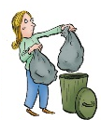
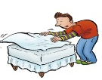


1. Make _______________ 2. Take _______________ 3. Do _______________
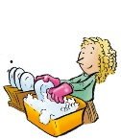

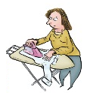
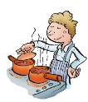

4. Wash _______________ 5. Iron _______________ 6. Cook______________

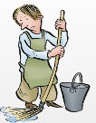
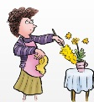
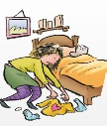

7. Clean _______________ 8. Mop_______________ 9. Tidy______________

2. Now, describe your responsibilities around your house.

3. Study the following expressions:

My house chores are…
My daily tasks are …
My responsibilities around my house are ….

Note:

take responsibility for (something)
The phrase "take responsibility" means to accept the negative consequences of a mistake. In other words, if there's a problem, you either fix it yourself or "take responsibility" is used in the following ways:
- take responsibility for (oneself)
You've got to start to take responsibility for yourself!
- take responsibility for (one's actions)
You need to learn to take responsibility for your own mistakes.
- take responsibility for (doing something wrong)
I think that, if anyone, Amy should be the one to take responsibility for losing the account.
- take full responsibility
Please forgive me. I take full responsibility.

4. Now, describe your responsibilities around your house as well as your friends in your group.

My chores | My friend’s chores (1) | My friend’s chores (2) | My friend’s chores (3)

